China Wireless Telecommunication Standard (CWTS);
Working Group 1 (WG1); Physical layer - General description

Physical layer - General description

TS C101 V3.0.0 (1999-10)
Technical Specification

Contents
1 Scope 3
2 References 3
3 Definitions, symbols and abbreviations 3
3.1 Definitions 3
3.2 Symbols 4
3.3 Abbreviations 4
4. Document structure of physical layer specification 5
4.1. Overview 5
4.2 C101: Physical layer – General description 5
4.3 C102: Physical channels and mapping of transport channels onto physical channels 5
4.4 C103: Multiplexing and channel coding 5
4.5 C104: Spreading and modulation 5
4.6 C105: Physical layer procedures 5
4.7 C106: Physical layer - Measurements 6
5 General description of Layer 1 6
5.1 Relation to other layers 6
5.1.1 General Protocol Architecture 6
5.1.2 Service provided to upper layer 7
5.2 General description of Layer 1 8
5.2.1 Multiple Access 8
5.2.2 Coding and interleaving 8
5.2.3 Modulation and spreading 8
5.2.4 Transmission and reception 9
5.2.5 Physical layer procedures 9
History 9

1 Scope
This specification describes the documents being produced by the CWTS WG1 and first complete versions expected to be available by end of 1999. This specification gives also general description of the physical layer of the TD-SCDMA air interface,

The C series specifies Um point for the 3G TD-SCDMA mobile system. This series defines the minimum level of specifications required for basic connections in terms of mutual connectivity and compatibility.

2 References
The following documents contain provisions which, through reference in this text, constitute of the present document.
- 3GPP RAN S1.02 (V1.0.0): “User Equipment physical layer capabilities”
- 3GPP RAN S1.21 (V2.1.0): “Physical channels and mapping of transport channels onto physical channels (TDD)”
- 3GPP RAN S1.22 (V2.1.0): “Multiplexing and channel coding (TDD)”
- 3GPP RAN S1.23 (V2.1.0): “Spreading and modulation (TDD)”
- 3GPP RAN S1.24 (V2.1.0): “Physical layer procedures (TDD)”
- 3GPP RAN S1.31 (V0.1.0): “Physical layer - Measurements”
- 3GPP RAN S2.01 (V2.0.0): “Radio Interface Protocol Architecture”
- CWTS WG1 TS C102(V3.0.0): “Physical channels and mapping of transport channels onto physical channels”
- CWTS WG1 TS C103(V3.0.0): “Multiplexing and channel coding”
- CWTS WG1 TS C104(V3.0.0) : “Spreading and modulation”
- CWTS WG1 TS C105(V3.0.0) : “Physical layer procedures”
- CWTS WG1 TS C106(V2.0.0) : “Physical layer - Measurements”
- CWTS WG1 TS C401(V3.0.0) : “UE Radio transmission and reception”
- CWTS WG1 TS C402(V3.0.0) : “BTS Radio transmission and reception”

3 Definitions, symbols and abbreviations

3.1 Definitions
For the purposes of the present document, the [following] terms and definitions [given in ... and the following] apply.
<defined term>: <definition>.
Example: text used to clarify abstract rules by applying them literally.

3.2 Symbols
For the purposes of the present document, the following symbols apply:
<Symbol> <Explanation>

3.3 Abbreviations
For the purposes of the present document, the following abbreviations apply:
BER Bit Error Rate
C- Control-
CCTrCH Coded Composite Transport Channel
DC Dedicated Control (SAP)
DCA Dynamic channel allocation
DCH Dedicated Channel
DS-CDMA Direct-Sequence Code Division Multiple Access
FDD Frequency Division Duplex
FEC Forward Error Correction
FER Frame Error Rate
GC General Control (SAP)
GSM Global System for Mobile Communication
L1 Layer 1 (physical layer)
L2 Layer 2 (data link layer)
L3 Layer 3 (network layer)
MAC Medium Access Control
Mcps Mega Chip Per Second
Nt Notification (SAP)
ODMA Opportunity Driven Multiple Access
PCS Personal Communications System
PHS Personal Handyphone System
PHY Physical layer
QPSK Quaternary Phase Shift Keying
RACH Random Access Channel
RF Radio Frequency
RLC Radio Link Control
RRC Radio Resource Control
SAP Service Access Point
SCH Synchronization Channel
SIR Signal-to-Interference Ratio
TDD Time Division Duplex
TDMA Time Division Multiple Access
TD-SCDMA Time Division Synchronous CDMA
U- User-
UE User Equipment
Um U interface in a mobile network
UMTS Universal Mobile Telecommunications System
UTRA UMTS Terrestrial Radio Access

Document structure of physical layer specification

Overview
The physical layer specification consists of six general documents (this document, [8], [9], [10], [11] and [12]).

C101: Physical layer – General description
The scope is to describe:
- the contents of the Layer 1 documents (C1 series);
- where to find information;
- a general description of Layer 1.

4.3 C102: Physical channels and mapping of transport channels onto physical channels
The scope is to establish the characteristics of the Layer 1 transport channels and physical channels, and to define:
- transport channels;
- physical channels, structure and contents;
- timing relationship between physical channels;
- mapping of transport channels onto physical channels.

4.4 C103: Multiplexing and channel coding
The scope is to describe multiplexing, channel coding and interleaving, and to specify:
- channel coding;
- interleaving;
- rate matching;
- multiplexing.

4.5 C104: Spreading and modulation
The scope is to establish the characteristics of the spreading and modulation, and to specify:
- data modulation;
- spreading;
- generation of codes;

4.6 C105: Physical layer procedures
The scope is to establish the characteristics of the physical layer procedures, and to specify:
- BTS synchronisation;
- Random access;
- Uplink synchronisation;
- Beamforming for both uplink and downlink (Smart antenna);
- Dynamic channel allocation (DCA);
- Power control;

4.7 C106: Physical layer - Measurements
The scope is to specify:
- the measurements that Layer 1 is to perform;
- reporting of measurements to higher layers and network;
- handover measurements, idle-mode measurements, etc.

5 General description of Layer 1

5.1 Relation to other layers

5.1.1 General Protocol Architecture
Air-interface, which is prescribed by this specification, means the Um point between UE and network. Air-interface is composed of Layers 1, 2 and 3. Layer 1 is based on TD-SCDMA technology and the C1xx series describes the Layer 1 specification. The layer2 and layer3 should be the same as UTRA TDD mode.

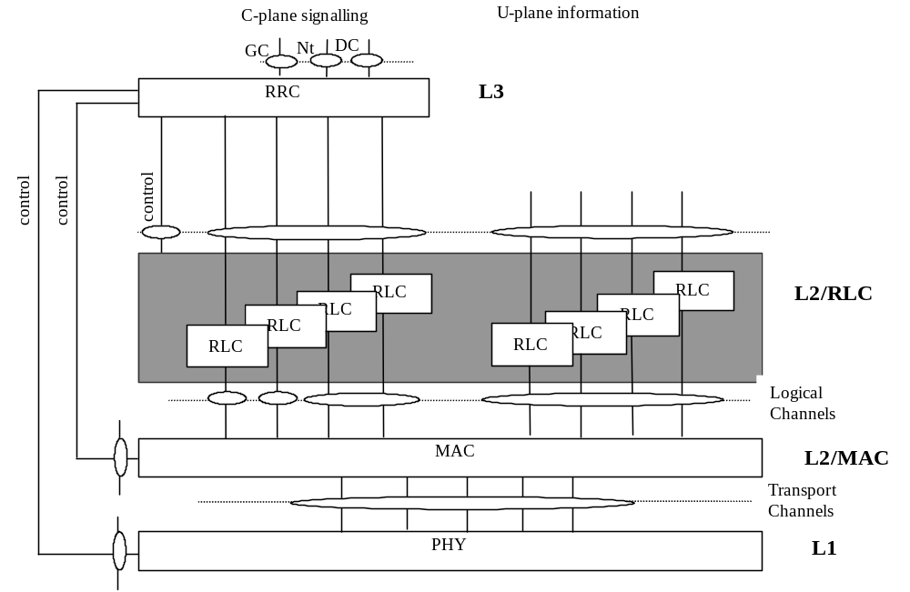

Figure 5-1. Radio interface protocol architecture (Service Access Points marked by circles)

Figure 5-1 shows the TD-SCDMA radio interface protocol architecture. The circles between different sub-layers indicate Service Access Points (SAPs). The physical layer (Layer 1) offers different Transport channels to L2/MAC. A transport channel is characterized by how the information is transferred over the radio interface. L2/MAC offers different Logical channels to L2/RLC. A logical channel is characterized by the type of information transferred. Physical channels are defined in the physical layer. The physical channels is characterized by the code, frequency and time slot. RRC controls RLC, MAC and Physical layer via primitives.

5.1.2 Service provided to upper layer
The physical layer offers data transport services to higher layers. The access to these services is through the use of transport channels via the MAC sub-layer. The physical layer is expected to perform the following functions in order to provide the data transport service.
- FEC encoding/decoding of transport channels
- Macrodiversity distribution/combining and handover execution
- Multiplexing/demultiplexing of transport channels and of coded composite transport channels
- Mapping of coded composite transport channels on physical channels
- Modulation and spreading/demodulation and despreading of physical channels
- Frequency and time (chip, bit, time slot, subframe) synchronization
- Power control
- Power weighting and combining of physical channels
- RF processing
- Error detection and control
- Rate matching (data multiplexed on DCH)
- Radio characteristics measurements including FER, SIR, Interference Power, etc.
- Uplink synchronization
- Beamforming for both uplink and downlink (Smart antenna)
- UE location/positioning (Smart antenna)
When network elements (UEs and network) provide compatible service bearers (for example supports a speech bearer) they should be assured of successful interworking. Moreover, different implementation options of the same (optional) feature would lead to incompatibility between UE and network. Therefore, this shall be avoided.

5.2 General description of Layer 1

5.2.1 Multiple Access
The access scheme is Direct-Sequence Code Division Multiple Access (DS-CDMA) with information spread over approximately 1.6 MHz bandwidth in TDD (Time Division Duplex) for operating with unpaired bands respectively. TDD mode is defined as follows:
TDD: A duplex method whereby forward link and reverse link transmissions are carried over same radio frequency by using synchronised time intervals. In the TDD, time slots in a physical channel are divided into transmission and reception part. Information on forward link and reverse link are transmitted reciprocally.
In TD-SCDMA, there is TDMA component in the multiple access in addition to DS-CDMA. Thus the multiple access has been also often denoted as TDMA/CDMA due to added TDMA nature.
The carrier separation is 1.6 MHz depending on the deployment scenario with 200 kHz carrier raster. A 10 ms radio frame is divided into two 5ms sub-frames. In each sub-frame, there are 7 main time slots and 3 special time slots. A basic physical channel is therefore characterized by the frequency, code and time slot. TD-SCDMA uses the same 72-frame superframe structure as suggested by UTRA.
The information rate of the channel varies with the symbol rate being derived from the 1.28 Mchips/s chiprate and the spreading factor. Spreading factors is from 16 to 1 for both uplink and downlink. Thus the respective modulation symbol rates vary from 80.0K symbols/s to 1.28M symbols/s.
Furthermore, relaying between nodes can be used by means of Opportunity Driven Multiple Access (ODMA).

5.2.2 Coding and interleaving
For the channel coding in TD-SCDMA two options are supported:
- Convolutional coding, either rate 1 to rate 1/3 for packet data and services requiring quality level 10-3 or lower over the physical layer with forward error correction (FEC).
- Turbo coding, for the transmission rate higher than 32 Kbps and service requirement services requiring higher than 10-3 quality level.

5.2.3 Modulation and spreading
The TD_SCDMA modulation scheme is QPSK (8PSK for 2Mbps and higher data service) with root raised cosine pulse shaping with roll-off factor 0.22.
With CDMA nature the spreading (& scrambling) process is closely associated with modulation. In TD-SCDMA, different families of spreading codes are used.
- For separating channels from same source, channelisation codes are used.
- For separating different base station the following solutions are supported:
- Gold codes in downlink Pilot, or
- Scrambling codes with the length 16 used as defined in [10].
- For separating different mobiles the following code families are defined:
- Codes with period of 16 chips and midamble sequences of 144 chips length.
- Gold codes in uplink pilot.

5.2.4 Transmission and reception
The TD-SCDMA frequency bands assumed for operation are:
Unpaired frequency band located at 2GHz;
Other frequency bands available;
6 UE transmission power classes are defined in [13]

5.2.5 Physical layer procedures
There are several physical layer procedures involved in TD-SCDMA operation. Such a procedures covered by physical layer description are:
- The power control, with both closed loop and open loop power control;
- Handover measurements for handover within TD-SCDMA mode;
- The measurement procedures for preparation for handover to GSM900/GSM1800;
- The measurement procedures for preparation for handover to other CDMA TDD/FDD mode(optional);
- Random access processing;
- Dynamic Channel Allocation (DCA);
- ODMA specific procedures such as probing (optional);
- Uplink synchronisation control with open and closed loop;
- Beamforming for both uplink and downlink (Smart antenna).
- UE location/positioning(Smart antenna).

History
Document history
V0.1.0 | 1999-04 | Document created based on the document CATT TD-SCDMA RTT V 0.5
V1.0.0 | 1999-05-08 | Document updated based on the 3GPP S1.01 V2.0.0 and the discussion between Siemens and CATT.  This draft has been discussed in the CWTS WG1 Ad Hoc1#1 meeting, Beijing, May 8th, 1999.
V1.1.0 | 1999-05-21 | Document updated based on the CWTS WG1#3 meeting, Beijing, May 21st, 1999.
V1.2.0 | 1999-07-22 | Revised after discussion
V2.0.0 | 1999-08-05 | Revised after discussion on the CWTS WG1 Ad Hoc1 #2 meeting, CUPT,5th,Aug.,1999
V2.1.0 | 1999-08-30 | Document updated based on the CWTS WG1 Ad Hoc1 #3 meeting, Beijing, 30th,Aug., 1999.
V2.2.0 | 1999-10-2 | Chip rate change to 1.28Mcps
V3.0.0 | 1999-10-14 | Document accepted by CWTS WG1 Ad Hoc1 #4 and CWTS WG1#5 meeting in Beijing, Oct.14, 1999
Editor for C101, Physical Layer – General Description, is:

Dr. Shihe Li
CATT
Email: lish@pub.tdscdma.com

This document is written in Microsoft Word 97.

